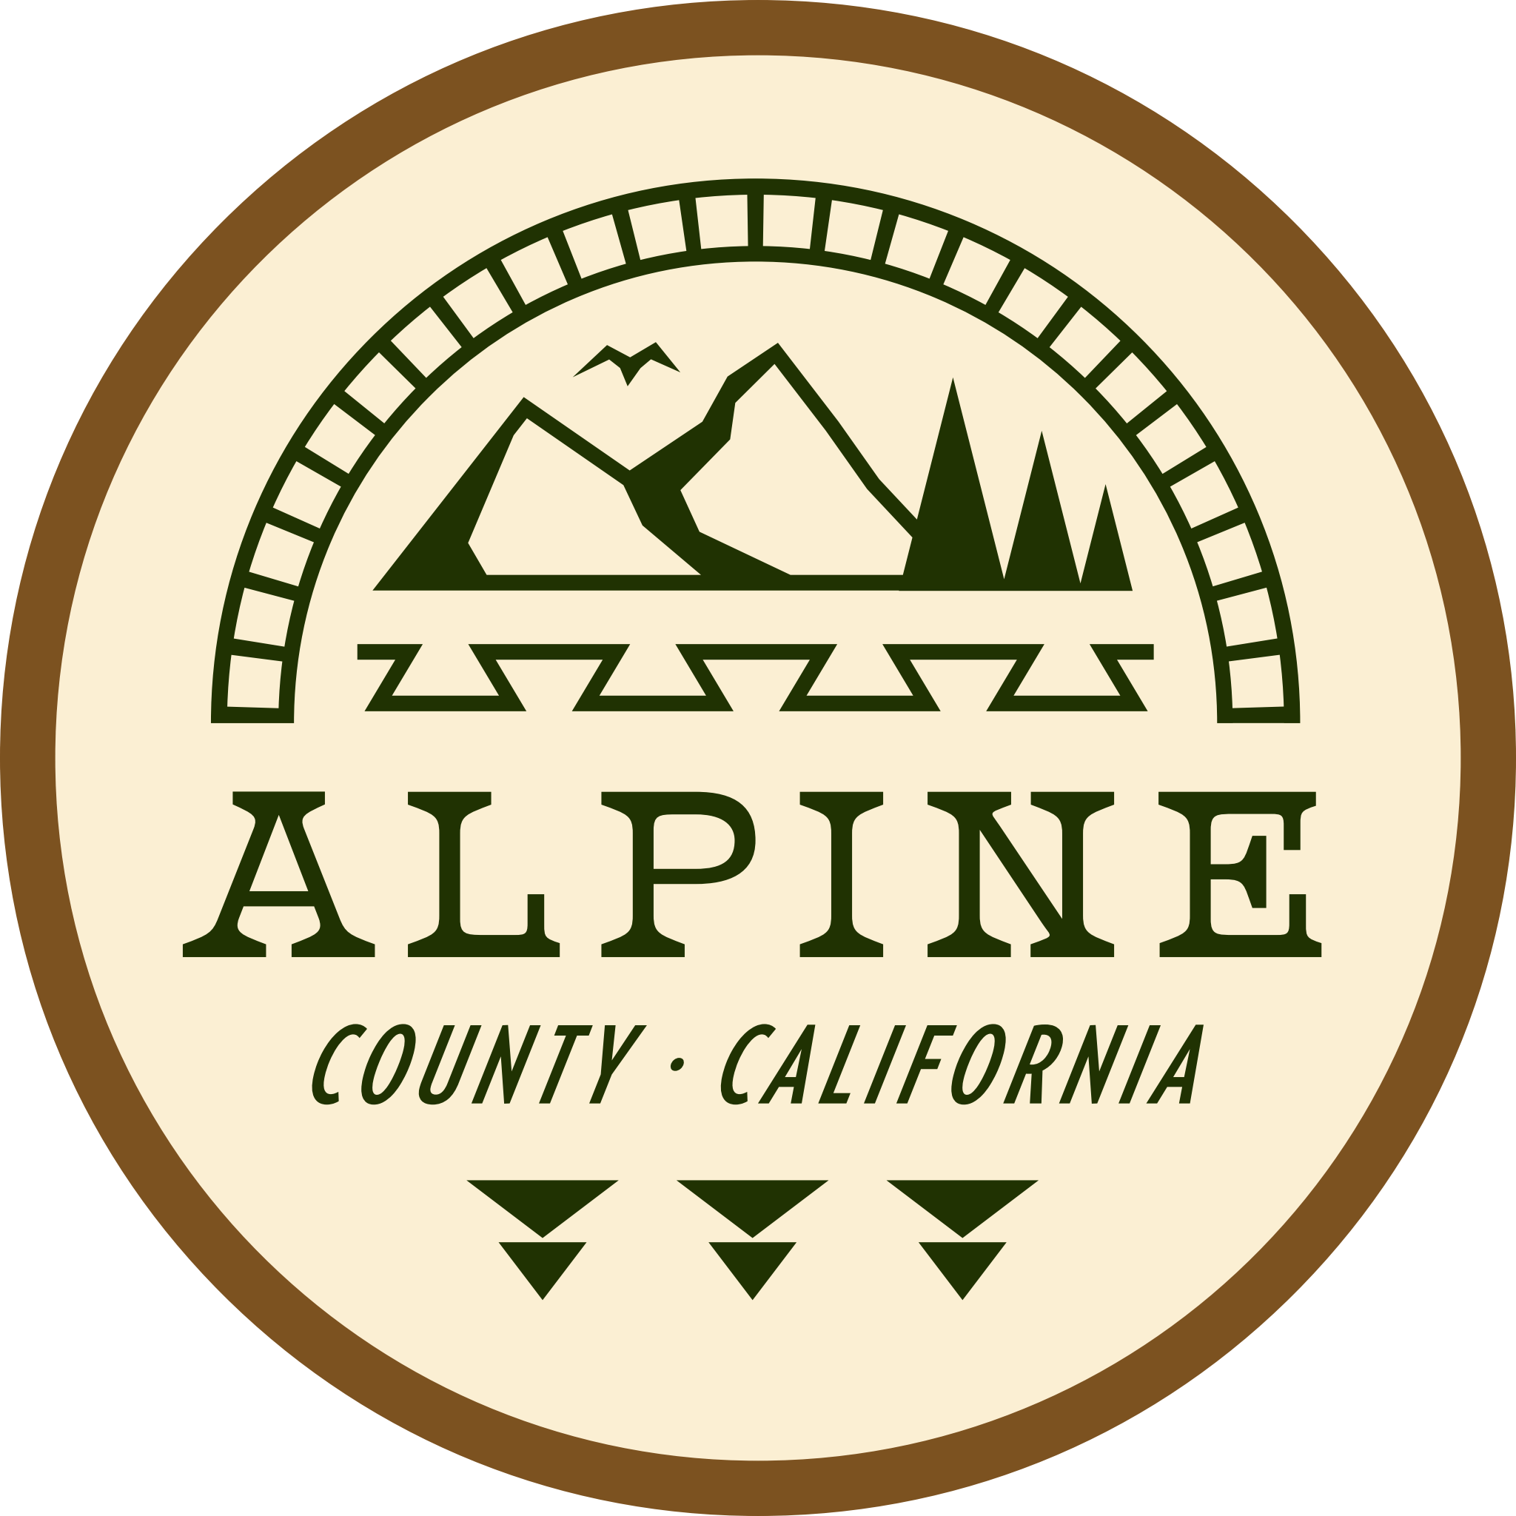
Alpine County Chamber of Commerce
Meeting Minutes March 21,2024

Board Members Present: Aaron Johnson, Carol Hannigan, Elizabeth Sears and Patrick Sarni
Public Present: Melissa Edwards, Ivy Villnow, John Smith Alpine Fish & Game, Todd Smith, January Riddle, Mark Scwartz, Kate & Richard Harvey, Amy Mecak, Andy Berkenfield, David Griffith, Kelly Keith of Vail/Kirkwood, Geoff Ellis Woodfords Tribal Council, Jordan Lake Alpine Resort, Emily Graham Sierra K16 Sierra Collaborative, Phil Carson River Resort, Andy Lovell ATA, Lewis Ames
Actionable Items:
Board to discuss and approve fish plant contribution for 2024
Present rental agreement after Carol & Meghan determines available rentable equipment
Distribute JT Chevallier economic statement and timeline with video link for, Are you Alpine
Public Comment:
-Geoff Ellis Woodfords Community Tribal Council Member- Tribe to support the Chamber in events and want to coordinate to support children from the community and Diamond Valley school: art projects, bike days
-John Smith Alpine County Fish & Game- Requesting chamber member list. Fishing derby days 2-3 for 2024. Price of fish went up, requesting for chamber 2024 support dollar amount. Fishing scheduled to open last Saturday of April. Support from Todd, Phil.
-Lake Alpine Jordan, looking for Forest interpreters for this season
-Emily Graham with Eastern Sierra K16 Collaborative seeking to get familiar with county and the needs. Visiting 4/12
-Art Council, January Riddle announced monthly featured local artist display at Markleeville Library with reception.
Consent agenda: Minutes January 18, 2024, approved Lisa voted, Patrick second
Old Business
-Financials 2024: Budget submitted to board after Meghan & Carol reviewed, Aaron happy with the Death Ride 2024 projections. Death Ride medical & cal trans agreements being revisited for decrease in cost. Approved.
Chamber/Visitors Center update- Winter hours to extend through April. Post for PT office work with skills. Members alerted to bear break-in at dumpster.
New Business
Death Ride 2024- Cal Trans meeting to discuss permits fees with County support scheduled 3/22. Melissa updated on marketing campaigns for emails & social media as well as cross promotions with other clubs and rides. Good feedback on Marks Blogs. Registered riders 943. Alta Alpina agreement drafts are in final edits, Aaron and Alta Alpina president Bruse Eisner to sign final agreement.
Bylaw review- Equipment rental is obtainable. Meghan and Carol to draft list and agreement.
Standing Items:
Membership Renewal: Membership drive will send out second notice in April. Visitors Guide going to print April.
Events -Chamber Visitors Center Open house announced 3/27 and 4/30 event discussions and collaboration. Death Ride, Aspen Festival, Washoe Mountain Gathering, Fish Derby Day. If open house successful will extend to monthly.
Next Chamber Board Meeting – Markleeville Mixer Carson River Resort May 16th, check website for details.

